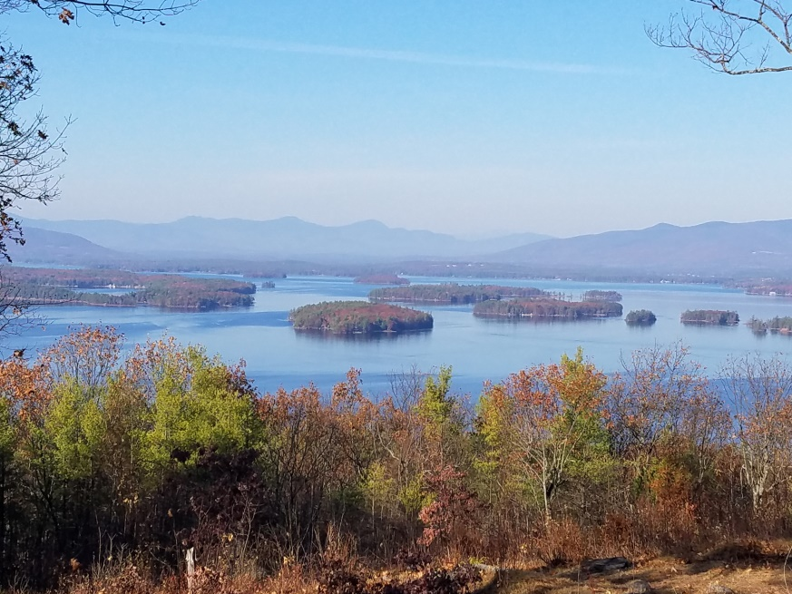
KIMBALL WILDLIFE FOREST COMMITTEE
MEETING Agenda: August 19, 2021 4:00 PM
Gilford Town Hall Conference Room or Zoom
- Attendance
- Approval of minutes – July 22, 2021
- Old Business:
- Recognition of John Colby: Rescheduled to September 16
- Review and Discussion of proposal from Erin Amadon, Town 4 Trail Services, LLC Troy, Maine for switchback trail work on Lakeview Trail. (Scott will provide an update.)
- Updates on Carye Trail improvements: Karl Gould
- Update on Trail Map editing (Pat and Sandy)

4. New Business
Next Meeting- September 16, 2021

