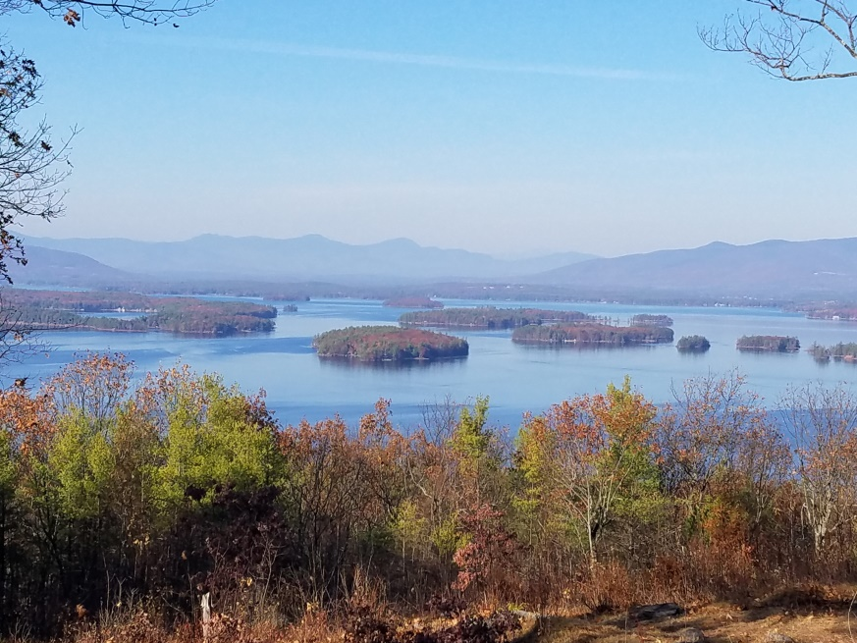
KIMBALL WILDLIFE FOREST COMMITTEE
MEETING Agenda: August 24, 2023; 4:00 PM
Gilford Town Hall Conference Room
- Attendance
- Approval of minutes – July 20, 2023
- Introductions
- Update on Interpretive sign proposal from Jennifer Woodward
- Trail updates: Tree cutting for safety access (Tim Nolin)
- Kiosk plans: Construction and content of the sign
Next meeting: September 21, 2023

