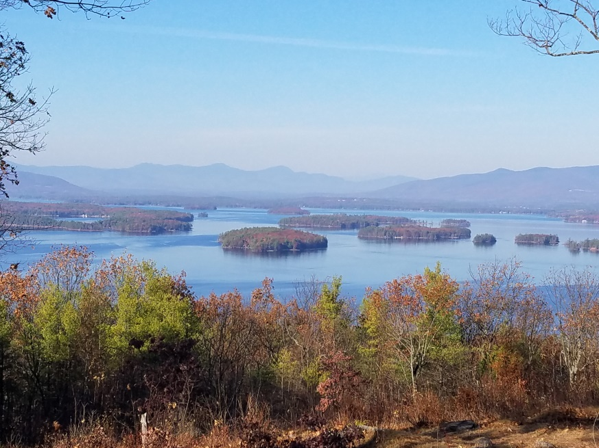
KIMBALL WILDLIFE FOREST COMMITTEE
MEETING Agenda: August 4, 2022; 4:00 PM
Gilford Town Hall Conference Room or Zoom
- Attendance
- Approval of minutes – May 26, 2022
- Old Business:
- Trail Updates-Karl
- Status of maps/trail guides
4. New Business
- Discussion on the summary and recommendations from Rebecca on the Hike with Denise and Paul Pouliot
- Updates on Trail 4 Trail Services project (Erin Amadon) timelines…signage in preparation for construction.
- Discussion on question from Erin Amidon asking if there are any limitations for working on the Kimball Forest Trails with regard to potential impacts on bad habitat.
5. Other
Next meeting: Thursday, September 15, 2022

