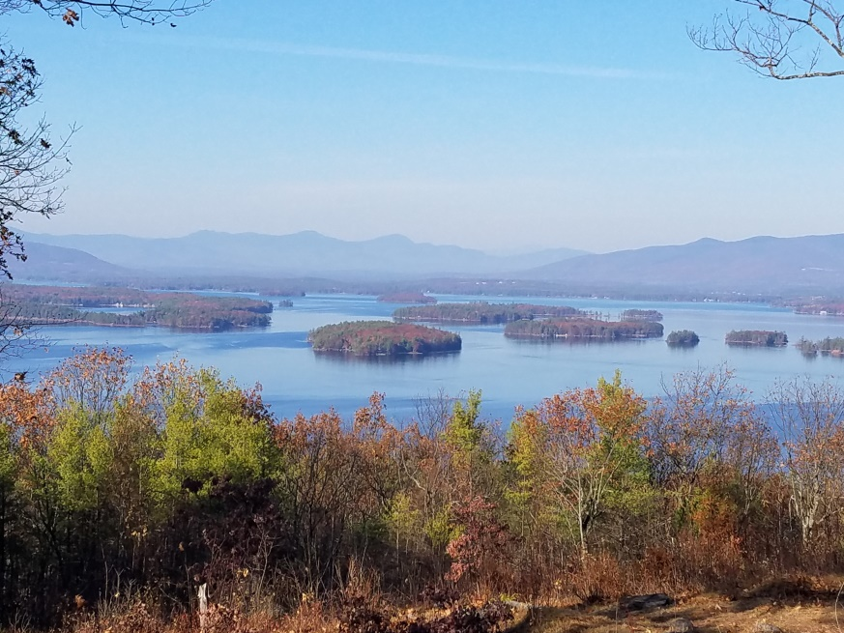
KIMBALL WILDLIFE FOREST COMMITTEE
MEETING Agenda: September 15, 2022; 4:00 PM
Gilford Town Hall Conference Room or Zoom
- Attendance
- Approval of minutes – August 4, 2022
- Old Business:
- Trail Updates-Karl
4. New Business
- Updates on Town 4 Trail Services project (Erin Amadon) timelines
5. Other
Next meeting: Thursday, October 20, 2022

