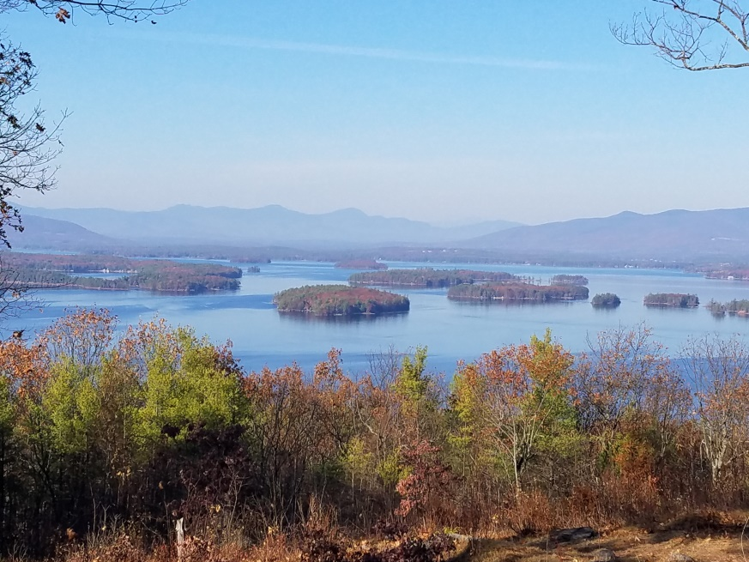
KIMBALL WILDLIFE FOREST COMMITTEE
MEETING Agenda: January 27, 2021 4:00 PM
Gilford Town Hall Conference Room or Zoom
- Attendance
- Approval of minutes – December 16, 2021
- Old Business:
- Trail Updates-Karl
- Trail Guide Updates-Pat and Sandy
4. New Business
- Update on potential habitat improvements, including the potential expansion of the oak savanna.
- Update of the indigenous history of KWF: Rebecca
5. Other
Next Meeting- February 17, 2022

