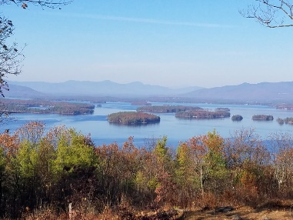
KIMBALL WILDLIFE FOREST COMMITTEE
MEETING Minutes: October 21, 2021 4:00 PM
Gilford Town Hall Conference Room or Zoom
- Attendance: Rebecca Watson, Dan Tinkham, Scott Dunn, Rebecca DiGirolomo (on Zoom), Sandra McGonagle, Pat Bennett and guest Gail Tebbetts

Sandy introduced our guest, Gail Tebbetts, who is interested in becoming a member of the KWF Committee. Gail is a Gilford resident and an avid hiker.
Scott explained the process for becoming a member of the committee. Gail will follow-up and Scott will submit her name to the Board of Selectmen.

- Approval of minutes – September 23, 2021
Moved by Rebecca Watson; seconded by Sandy McGonagle; minutes approved.

- Action on proposal from Erin Amadon, Town 4 Trail Services, LLC Troy, Maine for switchback trail work on Lakeview Trail.
Scott Dunn reported that the proposal had gone before the Board of Selectmen and that the Board had approved the dollar amount to be taken from the trust fund.
The committee inquired about the schematic requested of Erin and, with help from Dan, it was forwarded to Sandy. She will disseminate it to the committee.
Rebecca Watson then proposed a motion that the committee, having accepted the proposal, request that the Board of Selectmen authorize the payment of 10% or $1897.10 requested as a deposit. The proposal was seconded and approved.

Sandy asked Rebecca D. if she would report on her recent visit to the trails with Matt Tarr, wildlife biologist with the UNH Cooperative Extension Service. Regarding the current interpretive signs along the trail, she reported that only sign #15 (A Disturbed Life) seemed inappropriate. Sign #7 (A Patchwork Landscape) is missing but she felt the information is still appropriate.
Rebecca then expressed an interest in considering the addition of signage focusing on a wildlife opening near the top between signs #10 and #11. She and Matt felt that there was an excellent opportunity to fairly easily expand the area near the power line where the prescribed burn had been done. This is an area that they feel would prove very beneficial as a wildlife habit. It also could provide some additional views if some thinning were to be done. Rebecca indicated she felt that there might be grant money available to expand this area. The committee encouraged Rebecca to pursue this suggestion further. She will reach out to Tim Nolan, forester, NH Fish and Game and other natural wildlife resources to explore the feasibility of such a project. She is enthusiastic about the unique opportunities this area could provide.
There was a brief discussion of signage to highlight this wildlife area. The
Committee might consider either adding additional numbered, interpretive
signage or creating a stand-alone sign/arrow directing hikers to the spot.

- Updates on Carye Trail improvements
There was no update as Karl Gould was not in attendance.

- New Business
5. Other
Next Meeting- November 18, 2021
Respectfully submitted,
Patricia Bennett

