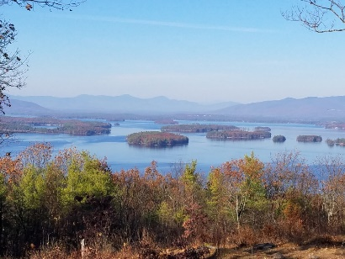
KIMBALL WILDLIFE FOREST COMMITTEE
MEETING Minutes: September 15, 2022; 4:00 PM
REVISED
Gilford Town Hall Conference Room or Zoom
- Attendance: Alexandra Breed, Dan Tinkham, Karl Gould, Tim Nolin (Zoom), Rebecca DiGirolomo (Zoom), Scott Dunn, Sandra McGonagle, Pat Bennett
- Approval of minutes – August 4, 2022
Moved by Alexandra Breed; seconded by Sandra McGonagle; approved
- Old Business:
- Trail Updates-Karl
Karl reported that he moved some stone at the first switchback to again try to keep hikers on the trail.
Based on a question from Sandy, it was agreed to have the Scouts do a sweep in October. Alexandra asked about reblazing of the trails. Karl will connect with BRATTS to do that.
Alexandra has volunteered to handle maps for the trailhead mailbox. Thanks!
4. New Business
- Updates on Town 4 Trail Services project (Erin Amadon) timelines
Dan reported that Erin apologizes but she cannot do the trail reconstruction project this fall. But she has flagged the trail and noted that there will have to be two sets of stairs. If we wish to continue with her, we would be first in line for the work to be done between March and May, next spring. The committee was in agreement to continue with Erin.
Discussion followed with regard to aspects of the spring project, which is expected to take 3-4 weeks. Relative to possible trail closures, Erin feels that the trail could remain open for most of the project with the exception of maybe a few days. Signage and perhaps some tape could be used to keep hikers clear of the work area.
Use of the parking lot was also questioned. Erin will park her large trailer off the premises. There will be minimal staging in the parking lot and she does not anticipate leaving anything overnight.
There was discussion about the need for some crushed stone, which was not in the bid, and Scott suggested the town might be able to help with that.
- Other
- Continuing a discussion from the last meeting, it was reported that a few hikers have not “carried out” their green dog waste bags. Tim noted that it seems to be a problem everywhere and Rebecca also commented that some places have used very strong language on the subject. Alexandra shared a photo of a sign she had seen that encouraged hikers to “carry out” in a fun way – “there is no such thing as a dog fairy.” The committee will inquire about having a similar sign printed.
- Rebecca updated the committee on a prescribed burn proposal. She has contacted her resource but has not yet received a response.
- Karl has done some trimming at the first overlook but questioned the need for more. There was discussion about what trees and where to cut. Tim can do saplings but not bigger trees. The glades area was also mentioned as was an area of growth on the Quarry Trail where some clearing had been done a number of years back. Alexandra questioned whether it needed brush hogging but Rebecca suggested that we may want to let it go a few more years, especially from a habitat perspective.
- Tim pointed out that he completed blazing the boundaries. Alexandra questioned some potential encroachment on the forest boundaries behind the trailer park off of Lockes Hill Road. Scott suggested that we should not be too concerned unless it were to involve structures.
Next meeting: Thursday, October 20, 2022

Respectfully submitted,
Pat Bennett

