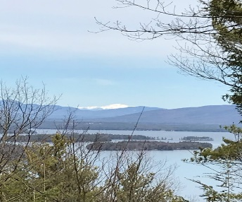
KIMBALL WILDLIFE FOREST COMMITTEE
MEETING Minutes
December 3, 2020 4:00 PM
Virtual Session on Zoom
- Attendance: Alexandra Breed, Rebecca Watson, Scott Dunn, Rebecca DiGirolomo, Sandra McGonagle, Pat Bennett. Unable to attend: Dan Tinkham. Unable to contact: George LaBonte

- Approval of minutes – October 15, 2020
Moved by Alexandra Breed; seconded by Rebecca Watson; minutes approved.

- Trail Activity:
- Scout Troops assistance in Trail clean-up
The Scouts have raked the trails and worked on the water bars. BRATT is expected to continue work on the water bars before winter sets in. Alexandra questioned work to remove the cut-offs and it was noted that the committee is pursuing a company to do some of that work.

- Report from Dan on Contacts for Trail Improvements
Dan was not present to give a report.

- Missing Demonstration Sign #7
Scott reported that he has a set of signs, except for #10. Alexandra noted that sign #4 is damaged. Sandy will research where the signs were made. It was suggested that we get another set made. Alexandra recommended that we might want to make sure that all of the information is up-to-date before we do so.
Tomorrow, Rebecca D. will be meeting at the trail with John Neely, who coordinated the burn on the trail a few years ago. They will observe the area of the previous burn and discuss any possible follow-up for maintenance of the area. She will check out some of the signage at the same time.

Rebecca D. has forwarded a pdf. of the signs to Scott.

- Porta Potty Update
Scott reported that the company that cleans the Porta Potty has suggested it no longer needs cleaning twice a week as it did this summer. The company will monitor it and revise the cleaning schedule accordingly.

- Castle Update- Scott Dunn No updates.

- Old Business:
- Recognition for John Colby
Dan Tinkham is giving some thought to this but Scott offered the suggestion
that an appropriate spot for a sign might be in the clearing near the top.

- Signage at the junction of Carye Trail and Carriage Road
Scott has received the new signs which will be used to identify where the KWF property ends and the private castle property begins. He will contact Tim Nolin and ask him if he would install the signs since Tim knows exactly where the boundary is. The replacement Lakeview sign also needs installation.

- Updates of Forest Management Plan-Tim
Tim will be working on this with the committee.

- New Business
Following a question by Alexandra relative to trail renovation, Sandy recommended that we focus our January and February meetings on looking at the strengths and weaknesses of our trail system and then selecting a company/organization to do the necessary trail restructuring work. Rebecca D. had previously forwarded some possible resources and Dan is doing research as well.

Notes:
- Rebecca W. has sent a request to George LaBonte’s Facebook page in another effort to try to connect with him.
- Sandy will reach out to John Colby’s son to get his thoughts on a form of recognition.

- Next Meeting- January 21, 2020
Respectfully submitted,
Pat Bennett

