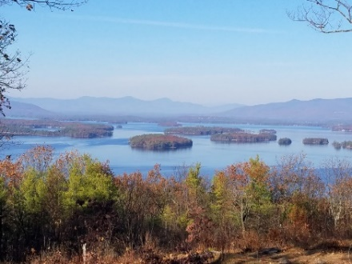
KIMBALL WILDLIFE FOREST COMMITTEE
MEETING Minutes:
April 22, 2021 4:00 PM; ZOOM
- Attendance: Dan Tinkham, Rebecca Watson, Scott Dunn, Rebecca DiGirolomo,
Sandra McGonagle, Pat Bennett
- Approval of minutes – April 1, 2021
Moved by Rebecca Watson; seconded by Sandy McGonagle; minutes approved
- Old Business:
- Update on Recognition for John Colby: John Colby A true friend and steward of the Kimball Wildlife Forest and Lockes Hill Trails.
- Update on meeting with Erin Amadon, Town 4 Trail Services, LLC Troy, Maine to discuss scope of services for switchback trail work on Lakeview Trail.
- Updates on Carye Trail improvements
The bench to recognize John Colby was delivered to Scott and he has taken it to
Charlie Beede, engraver, who will advise us as to what he can/cannot do and give us a
quote. Scott noted that there is very little smooth space on the bench’s surface. We
may need to reconsider the use of a plaque or sign. Sandy will update the committee.

Dan and Rebecca Watson joined Erin Amadon to walk the trails on April 19th. They
concentrated on the switchbacks on the Lakeview Trail. Switchbacks are a common
problem and Erin offered suggestions, especially the idea of going around the old
switchbacks with 1 or 2 larger ones – this makes it clearer for people to identify.
While this meeting concentrated on switchbacks, there was discussion about
improving trail design from the lookout area to the top to eliminate “trail creep.” This
might be considered as Phase 2 of any project.

The switchback work would probably require use of a small excavator and would take
about a month. Erin noted that it would probably be next summer before they could do the work. The committee agreed to proceed with having Erin draw up a trail layout and proposal for this work. There was no charge for the consultation on the 19th.
It was suggested that Erin be invited to our next meeting. Dan will follow up on that.
Sandy raised the question of tying up the trails if the work had to be done during the
summer. It was pointed out that Mt. Major closed their trails while work was going on.
Rebecca W. offered the suggestion of just closing the Lakeview Trail but leaving the Quarry Trail open. There is also the need to consider parking space for construction
equipment.

Scott recommended that we get a number from Erin and proceed from there.

With regard to the Carye Trail, Sandy reported that she has still been unable to connect
with Chris Prior of NEFF. She has, however, been given the name of an assistant and
will pursue that contact.

- New Business:
- Recreational Trails Program Grant: (RTP): recommended for consideration by Dan. Workshop Wednesday, May 5. (No report.)
- Announcement from Dan: Lockes Hill Trails Adopter from BRATT, Ramona Corson
Sandy advised us that she will be attending the RTP workshop on May 5th. She asked
Rebecca D. if she was interested, and they discussed the possibility.

Dan reported that Ramon Corson is interested in being the trail’s adopter. She was
recommended to him by a friend from BRATT. Dan will forward Ramon’s email address to Sandy so that she can invite her to our next meeting.

Sandy brought up a discussion about signage. Dick Tapply had contacted her regarding
the source of our trail signs. Unfortunately no record can be found as to where the signs
were printed. Discussion followed regarding possible sources for any new signs:
MegaPrint Inc. in Holderness, NH (suggested by Dan)
Gator Signs in Gilford
DPW or NH State Prison (suggested by Scott)
Sandy has a set of signs with the exception of numbers 10, 12, and 16. Then a question
arose about #16. While our current trail brochure map does not show a #16, it does
show on a previous map and is the Log Landing sign – last sign at the bottom of the
Quarry Trail.

- Next Meeting- May 20, 2021
There was discussion about returning to the Town Hall for this meeting. If so, there is easy access to Zoom for those who cannot attend in person. Rebecca D. advised that she will have to continue to Zoom.
Respectfully submitted,

Pat Bennett

