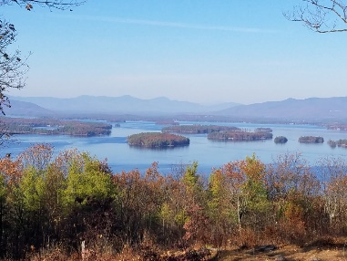
KIMBALL WILDLIFE FOREST COMMITTEE
MEETING Minutes: May 18, 2023; 4:00 PM
Gilford Town Hall Conference Room
- Attendance: Alexandra Breed, Carl Gould, Scott Dunn, Sandra McGonagle, Pat Bennett

- Approval of minutes – April 6, 2023
Due to the lack of a quorum, approval of minutes is moved the next meeting.

- Review and discuss updates to the trail map, demonstration signs and other signs at Lockes Hill Trails.
- Review Committee report from meeting with Matt Tarr

Sandy briefly reviewed Matt Tarr’s suggestions for signage. His focus included 1) identity of the habitat, 2) tree species, and 3)unique role of the species. Additional signage might reflect indigenous use (1 sign), stone walls, the glade, mountain and island vistas, and the quarry.

- Advice from Jennifer Woodward regarding wording of Interpretive Signs

Sandy spoke with Jennifer Woodward. While Jennifer is not a wildlife biologist, she has a passion for nature. Her background includes work in Massachusetts with the arboretum and Drumlin Farm, and with Prescott Farm here in NH. Most recently she has created signage at the Brewster Heath Preserve in Wolfeboro. She likes working with Mega Print as a source for styles of signs. She hikes Lockes Hill frequently and would be interested in working with us. In order to be able to meet with her, the next KWF meeting will be rescheduled to Thursday, June 29th.

In discussion regarding the kiosk for the trail head, it was suggested that Dan might hopefully be willing to help with the construction. With regard to content, Alexandra commented that she did not think information on the castle should be included. Also, Sandy noted that she feels the existing sign at the trail head does a good job on the history.

- Update on Lakeview Trail Work (Erin Amadon): Update from Dan.

The Lakeview Trail will be closed on Sunday night for several days.
Dan will put screening at the top and bottom of the trail. Erin is due back
on-site the 23rd.

- Recommended action from Erin Amadon to cut other trees on the Lakeview Trail for safety and hiker access. (Tim Nolin)

Scott recommended that Erin tag the trees and then we would contact Tim about getting them cut. Carl added that there are a couple of trees on the Quarry Trail that need to be cut. Scott suggested he tag those also.

- NH Tree Farm Inspection- June 6-7, 2023
- Master Plan Update: Review and Discussion
The Master Plan is up-to-date.

In addition, Scott advised the committee that Tim has approval to clarify the boundary lines in the area of Sagamore Road.

- Visitation day schedule
Apparently, Tim Nolan has been working on coordinating the visitation but Sandy will contact Rita Carroll, hoping to set the date for the 5th or 6th.
Next meeting: June 15, 2023 NOTE: Revised meeting date set for June 29.
Respectfully submitted,

Pat Bennett

