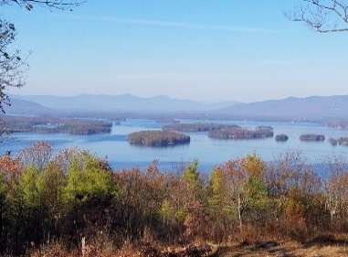
KIMBALL WILDLIFE FOREST COMMITTEE
MEETING Minutes: June 17, 2021 4:00 PM
Gilford Town Hall Conference Room or Zoom
- Attendance: Alexandra Breed, Rebecca Watson, Dan Tinkham, Scott Dunn, Karl Gould, Sandra McGonagle, Pat Bennett

- Approval of minutes – May 20, 2021
Moved by Alexandra Breed; seconded by Rebecca Watson; minutes approved
- Old Business:
- Update on recognition of John Colby
Scott showed us the commemorative sign created by Gator Signs of Gilford. The
committee was pleased with the design. It was suggested that we consider using
them for future sign work.

Scott and Sandy will go up to the suggested area near the top of the trail and pick a
spot for the bench and sign. Scott will then make arrangements with the DPW for
installation. A date will be selected, perhaps in August, for a recognition ceremony to
which John’s son and the Goulds (who donated the bench) will be invited.

- Update on meeting with Erin Amadon, Town 4 Trail Services, LLC Troy, Maine to scope of services for switchback trail work on Lakeview Trail.

Dan reported back that Erin had given him a price of about $3000 to prepare a design
proposal for construction work on the trail switchbacks to be based on construction
standards and equipment, etc. The following proposal was made by Scott Dunn and
seconded by Rebecca Watson:

Proposal: Engage Erin Amadon to prepare a design for trail construction, not to exceed $3000, to be submitted to the Board of Selectmen for approval.
The committee agreed to proceed. It was suggested that once approved, the committee
would review the proposal making sure that it reflects our intent. This might include a
tour of the site. It was also noted that if this project moves forward, construction
would probably not start until the fall of 2022, would take a month or more to
complete, and (given a rough estimate by Dan) probably cost $20,000 or more.
- Updates on Carye Trail improvements: See attached copies of emails from Karl Gould (BRATT) and Beth Gula (New England Forestry Foundation)
Karl reported on his recent first visit to the trail. He indicated that it was in need of
basic maintenance. Included in his comments were observations about downed trees,
brush, the need for work at water crossing areas, and use of surveyors’ tape in spots; but
he noted that he saw no signs of erosion at this point. Alexandra questioned beaver
activity around the pond. The possibility of BRATT working on this property was
discussed and Dan noted that it would need the approval of the BRATT Board. Sandy
thanked Karl for his assistance.

Sandy proposed a meeting between Beth and Karl at the trail, perhaps in July or
August. It was suggested that Peter Farrell and Dan might be included. Sandy also
apprised the committee that she had alerted the Scout Master regarding the
possibility of future assistance on the Carye Trail.

- New Business
Several continuing “projects” were noted: consideration of future signage, updating the map and brochure, and repainting of blazes. Karl will be redoing the blazes – staying with blue for both trails. Sandy reminded him to keep receipts for any supplies.

Next Meeting- July 15, 2021

Respectfully submitted,
Pat Bennett

