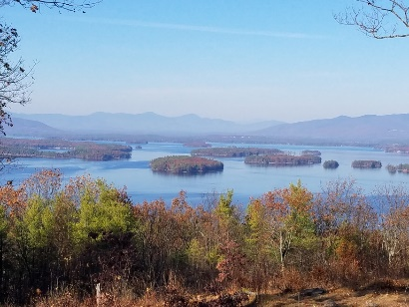
KIMBALL WILDLIFE FOREST COMMITTEE
MEETING Minutes: August 19, 2021 4:00 PM
Gilford Town Hall Conference Room or Zoom
- Attendance: Rebecca Watson, Alexandra Breed, Karl Gould, Scott Dunn, Rebecca DiGirolomo (in person - welcome!), Sandra McGonagle, Pat Bennett

- Approval of minutes – July 22, 2021
Moved by Alexandra Breed; seconded by Rebecca Watson; minutes approved.

- Old Business:
- Recognition of John Colby: Rescheduled to September 16
Sandy reported that a site has been designated for the bench; it is near the top with a view of the mountains to the north/west. September 16th is the goal for having the DPW do the installation. We had planned on having the recognition that day, the date of our next scheduled meeting, but Scott will be at a conference. The committee then decided to move the date of the next meeting and recognition to September 23rd. Sandy will be in contact with the Kyles and John’s son.
- Review and Discussion of proposal from Erin Amadon, Town 4 Trail Services, LLC Troy, Maine for switchback trail work on Lakeview Trail. (Scott will provide an update.)

Scott reported that he has spoken to Erin Amadon. She has agreed to draw up a proposal for the work and will have it for the scheduled September 16th meeting. Scott also noted that he is keeping the Board of Selectmen updated.

- Updates on Carye Trail improvements: Karl Gould
Sandy reported that Beth Gula (NEFF) has suggested that she can meet in mid-September to walk the Carye Trail. Due to continued issues surrounding the possibility of NEFF doing some lumbering on the property, Sandy will also contact Peter Farrell before proceeding. It appears as if NEFF and BRATT might be open to forming a relationship relative to the trail and its maintenance, but we need to make sure it is feasible to move forward at this point. Alexandra expressed an interest in participating in the walk.

- Update on Trail Map editing (Pat and Sandy)

Sandy and Pat met to look at possible revisions to the map and brochure.
(A list of possible suggestions was distributed.)
Discussion followed.
- Orient the map N/S on the page.
- Change the north arrow to a compass rose.
- Remove any trail markings that are not within the KWF boundaries, i.e.
the part of the Carye Trail NOT within the forest property. (Rebecca D.
note that permission is needed from a landowner to show trails on a map.)
- Change the shading on the map so as to separate surrounding property
from KWF property. (Rebecca D. suggested this.)
- Enlarge the map to a full sheet of paper. (By reworking some of the
brochure wording this can be accomplished.)
Rebecca D. has agreed to work on a revision of the map incorporating some of these suggestions which she will then distribute to us.

Other general discussion followed regarding maps and signage.
- Rebecca has agreed to check out each of the demonstration signs as to
its appropriateness. She will give us recommendations.
- Alexandra noted that the map should be on the town website. She also
suggested that we might want to look at the maps included on the Town
of Meredith website for additional ideas.
- Karl suggested that it might be good to create a sign educating people
about switchbacks (to coordinate with the work that will be done). This
also raised the point that the revised map should reflect the “new”
switchback.

Scott offered the recommendation that, since there are still things to be worked out with regard to the map/brochure revision, the committee might find it necessary to continue to print the current brochure, only in a smaller number, if we begin to run short.
4. New Business
Next Meeting- September 23, 2021. We will all meet up on the trail for the John Colby recognition.
PLEASE NOTE THE CHANGE IN DATE/LOCATION

