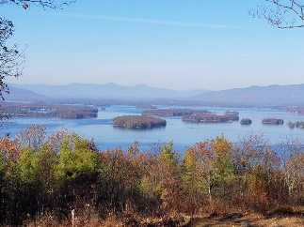
KIMBALL WILDLIFE FOREST COMMITTEE
MEETING Minutes: September 23, 2021 4:00 PM
Gilford Town Hall Conference Room or Zoom
NOTE: There was no formal agenda issued since we were supposed to be attending
the recognition for John Colby at the newly installed bench at the top of the trail. Due to the weather forecast that event was rescheduled for Sunday, September 26 at 2:00 PM. Instead, we did hold a regular meeting with one agenda item, as indicated below.

- Attendance: Alexandra Breed, Karl Gould, Scott Dunn, Sandra McGonagle, Pat
Bennett
- Approval of minutes - August 19, 2021
The minutes were not submitted for approval.
- Review of and action on the Proposal from Erin Amadon of Town 4 Trail Services
relative to switchback trail work on the Lakeview Trail.

Alexandra suggested that before we proceed, she be provided with a
schematic of the proposed site work area so that we could walk it and actually
view the site. She also stated that she would like to hear Dan’s feelings but feels the
cost is acceptable. In response to this request, Sandy contacted Erin by phone and
Erin agreed to do a schematic. She plans to do it on her way to Vermont on October
4th. Karl will discuss all of this with Dan.

- Additional business.

- Carye Trail
Alexandra asked if there was any further information on the Carye Trail. Once again Sandy noted that we are still waiting to make connections with Peter Farrell and Beth Gula of NEFF before we can go any further. Karl made a few comments about the condition of the trail especially near the beaver dam.

- Quarry Trail
Karl noted that the trail, where it crosses the quarry pool, is breaking up
and could use some repair. He is willing to attempt it but feels it requires
stonework. He agreed to see if BRATT might be able to offer some
assistance.

Additional suggestion:
A new trail map will need to reflect the switchback changes. Can Erin
Amadon’s schematic be coordinated with Rebecca D.’s proposed map
revision to reflect those changes?

Reminder: Rebecca DiGirolomo and Matt Tarr, State Wildlife Specialist, will be
hiking the trail on October 12th for the purpose of reviewing current signage then
making recommendations. They are inviting anyone interested to join them.

Next meeting: October 21, 2021

Respectfully submitted,

Patricia Bennett

